

Closing the World’s Investment Gap

**Initial Design Report**

Team Members  
Ameer Shaikh   
Amr Mahmud  
Daniel Kecman  
Stefan Momic

Contents

Problem Statement 4

Project Scope 5

Survey of Existing Solutions 5

Survey of Existing Solutions – Deeper Dive 6

Project Framework 8

Stakeholder Analysis 8

Step 1: Identify all Stakeholders 9

Step 2: Prioritize Stakeholders 9

Step 3: Understand your Stakeholders 10

Functions 11

Objectives and Constraints 12

Objectives 12

Constraints 12

Design Decisions 12

Business Logic 13

Asset Universe Selection 13

Source of Financial Data 13

Portfolio Generation Strategy 13

Parameter Estimation 13

Considerations for Robustness 13

Portfolio Validation and Analytics 13

Front-End 13

User Interface 13

Wireframe and Sketch of User Interface 13

Gathering User Input(s) and Feedback 13

Display of Computed Data 14

Decision on Technologies Used 14

Back-End 14

Storage of Financial Data (Both Raw and Computed Data) 14

Cleaning Data & Dealing with Missing Data 14

Choice of Database / Data Source for Raw Data 14

Setup of Data Access Layer for Data (Both Raw and Computed Data) 14

Hosting 14

Flow Chart and Decisions on Technologies Used 14

Analysis of Service Environment 14

Project Plan and Timeline 14

References 17

# Problem Statement

Money matters – love it or hate it, money has become a cornerstone to survival and society. Despite all the claims that “money doesn’t buy happiness” money is a critical component allowing one to pursue the life they want. Money provides us with the ability to satisfy our basic survival needs (i.e. food, shelter, clothing, etc.), creates opportunities for choices/flexibility, allows you to live your dreams and/or fund the causes you care about. By this point, we believe that we do not need to convince you about the importance of money, as we can appreciate that everyone had some concerns about money at some point or other. Rather, we are here to help you make money, so you can live the life you want!

Fundamentally, there are only two ways to make money – by working and/or by having your assets work for you. We all know the importance of working with most of us having jobs to satisfy our monetary needs, but having your assets work for you is something that most people often overlook. We are here to change that. Alpha Factory aims to reduce the stigma around investing and make it accessible and understandable for everyone. Ultimately, Alpha Factory aims to *close the world’s investment gap* by making investing activities part of everyday life!

Simply put, investing is the act of committing money or other assets to an endeavor with the expectation of obtaining an additional income or profit in the future. (Investopedia). Ultimately, investing allows you to further enhance your wealth as it provides you with the opportunity to earn a return on investment (i.e. additional money in the future). Conversely, if you don’t invest you are missing out on the opportunity for financial growth and/or asset appreciation.

There are many reasons to invest with as many different investment goals as there are people. Common reasons to invest your money include, but are not limited to the following:

1. Grow your money – return on your investments allows your money to build, creating additional wealth over time
2. Save for retirement – you may be working now, but we all know you cannot work forever. Saving money for retirement, and better yet, investing your retirement savings will allow you to live off these funds after you stop working
3. Earn higher returns – if you want to grow your money, you need to put it in a place that offers a higher rate of return than the interest rates provided by your savings account(s). With many investment vehicles (more on these later!) offering opportunities to earn higher rates of return, investing your money provides the opportunity to achieve these goals
4. Reach financial goals – whether these goals involve buying a home/car, putting your children through college, paying off loans and/or starting a business, having an additional source of income by investing your money will help you on that path

As you can see there are many different investment goals with as many, if not more, investment strategies to achieve them. We understand that this can be overwhelming for the average person, but that does not mean that investing should only be available to the few people who understand it. Everyone needs money, and everyone has some financial goals – Alpha Factory is here to help you invest in your future and make your money work for you!!

# Project Scope

With the plethora of different investment goals and strategies present Alpha Factory simply cannot generate portfolios to accommodate them all. As such, we have decided to focus in on a range of investors to optimally satisfy their needs. Luckily, we have decided to focus on you – the average member of the population!

Specifically, Alpha Factory aims to use our platform and proprietary portfolio generation techniques to help the average person with limited knowledge of the financial markets and/or limited time to manage their own asset portfolios/investments. Specifically, we aim to get to know you through our quick questionnaires, so we can create a personalized diversified portfolio of assets at a risk tolerance you are comfortable with while meeting your long-term investment goals. From there, we manage your money for you – this includes automatically rebalancing your portfolio to account for any market fluctuations and reinvesting your investment proceeds (e.g. dividends) to ensure that your money doesn’t take any breaks while working for you. We understand that investment goals change overtime and we offer dynamic portfolio modifications to address your evolving user preferences and inputs.

[MODIFY LATER AFTER SURVEY / MAKING DESIGN DECISIONS]

# Survey of Existing Solutions

Since the invention of the Internet we have greatly changed the way we work, learn and interact with each other – it is time we change the way we invest! In fact, this change is already well underway with several other robo-advisors already out there. Alpha Factory has learned a great deal from our competitors that have been first to market, and we aim to use these lessons learned to not only outperform them but outperform the market as well.

In surveying the existing solutions, we decided to limit our scope to a select number of robo-advisors based in Canada and the United States. Specifically, we decided to further explore Nest Wealth, BMO Smartfolio, Wealthsimple, Questrade Portfolio IQ and WealthBar as they were ranked the Best Canadian Robo-Advisors in 2018. (by greedyrates) Moving across the boarder, we decided to explore Betterment, Personal Capital, Schwab Intelligent Portfolios, SigFig and Wealthfront as they were ranked the Best Robo-Advisors in 2018 by Investopedia.

With changing consumer preferences, and an increasingly technological world, robo-advisors have surged in popularity. Robo-advisors ultimately allow everyday investors to set up a customized, diversified portfolio and provide access to a series of wealth management services that previously only seemed to be available for the ultra-wealthy and financially literate. With a growing selection of robo-advisors with seemingly new firms entering the market on a daily basis and veteran robo-advisors (like those already mentioned) expanding their offerings at a rapid pace, it has become increasingly difficult to pick the best robo-advisor.

In reality, with varying investment goals and preferences the best robo-advisor is a subjective matter highly dependent on the respective financial goals of each individual investor. However, after a comprehensive survey of the top 5 rated robo-advisors in both respective countries, it was noticed that the top-rated robo-advisors shared the following common features:

* Low initial investment – namely the ability to generate a robust and diverse portfolio without requiring massive capital involvement (in contrast, attaining a diverse portfolio of assets traditionally required a great amount of initial capital)
* Low fees – ultimately allowing the investors to retain most of the money their money earns
* Popular investment options – namely having a smaller universe of assets allowing the investors to be familiar with and understand the assets they invested their money in
* Comprehensive portfolio management features – especially those that allow the investors to feel like the portfolio generated is truly unique to their needs and created with their input

While creating Alpha Factory we were conscious about all four of these features and made all our design decisions to ensure that our users obtain all the features that made those robo-advisors a success. More than this, Alpha Factory aims to achieve better returns than the aforementioned robo-advisors with careful consideration of their asset universe, parameter estimation and portfolio generation methodologies.

## Survey of Existing Solutions – Deeper Dive

Prior to discussing Alpha Factory’s design and methodology we provide a deeper dive into each previously mentioned competitor. Alpha Factory ultimately used these competitors as case studies in creating their own design decisions. Note that this section can be skipped without much impact on subsequent sections.

1. Betterment LLC

With over $10B in assets under management (AUM), Betterment is one of the robo-advisor behemoths. What makes Betterment so appealing to inexperienced investors is that it has no minimum account balance for its basic plans, while still offering top-tier portfolio management services through its premium plans. Betterment also advertises that “you can potentially keep an additional 2.9% of your investor returns each year” because of their passive investing approach[1], minimal rebalancing and tax-efficient techniques.

Based on their risk questionnaire Betterment provides you with a customized portfolio of low-fee stock and bond index funds.

1. Personal Capital

Personal Capital aims to provide an all-in-one financial platform by allowing their clients to connect their existing bank accounts to the platform to track their spending and retirement savings on top of their portfolio’s performance. With over $5B in AUM, Personal Capital largely follows modern portfolio theory, namely Mean Variance Optimization (MVO) to construct the optimal portfolio of assets by maximizing the portfolio’s returns subject to customized risk constraints. As with Betterment, Personal Capital improves upon the basic MVO by employing tax loss harvesting and rebalancing.

It is worth noting that Personal Capital charges the highest fee (i.e. 0.89%) but justifies it by providing additional wealth/financial planning tools and a dedicated team of financial advisors.

1. Schwab Intelligent Portfolios

Schwab has disrupted the disruptive robo-advisor space by taking the low fees as low as they can go. That is, Schwab charges no account fees or commissions, rather earning money from Schwab ETFs and select third-party ETFs. It is worth noting that unlike the other robo-advisors discussed, Schwab does require a minimum $5,000 balance to open an account.

As with Betterment, Schwab creates custom portfolios of ETFs based on investor responses to their questionnaires and employs automatic rebalancing and tax loss harvesting for accounts with a value greater than $50,000.

It is worth noting that Schwab claims that the operating expenses investors pay for the ETFs in their portfolio are the same as they would have been if they invested in them on their own. As such, the operating expenses paid varies depending on the makeup of their portfolio and ranges anywhere from 0.03% to 0.40%.

1. SigFig

SigFig attempts to differentiate itself by catering to those with an existing online brokerage as it allows you to keep your existing investments with their robo-advisor creating an “intelligent, tax-efficient, diversified portfolio.” Like its peers, SigFig uses a risk-assessment questionnaire for creating customized portfolios for their clients. Like Schwab, SigFig has a minimum account balance of $2,000 and manages accounts under $10,000 for free but starts charging an account fee of 0.25% for any amounts greater (note that they only charge you on the portion exceeding $10,000).

1. Wealthfront

Like Betterment and Personal Capital, Wealthfront is a robo-advisor behemoth with over $7.5B in AUM and builds investors custom portfolios based on their answers to risk questionnaires. Like SigFig, Wealthfront manages your first $10,000 for free and charges 0.25% for amounts exceeding $10,000.

As with the other behemoths, Wealthfront offers a wide range of portfolio management services and various account types considering various nuances like tax-loss harvesting. For example, under this strategy, individual stocks representing an index are purchased instead of the index ETF such that they can be sold for tax-loss harvesting.

Alpha Factory considered the design decisions of these, and several other competitors in creating their own business plan – refer to Section XX. Decisions pertaining to management fees, initial investment balances, portfolio management features and asset selection was of particular interest during the comparison. Next, we turn our attention to the Canadian robo-advisors to further consider the asset selection based on the market that’s closer to home.

Looking at the Canadian counterparts we noticed that they also strived for the same common features as their American peers (namely, low initial investment, low fees, popular options and comprehensive personalized features) in various ways. For example, Nest Wealth aims to keep fees low by capping management fees a $80 regardless at how big your account grows, with the other four advertising management fees ranging from 0.35-0.70% and comparing the hypothetical returns you’d make with those lower fees with the 2.17% average mutual fund fee. (Questrade IQ).

Furthermore, all five of the robo-advisors considered offer customized portfolios matched based on each individual’s investment style, risk tolerance and savings goals and provide a different range of other features in an attempt of differentiation. Additionally, they all cited “overwhelming research” suggesting that passive investment outperforms active investors attempting to beat the market, with Nest Wealth summarizing it best saying, “using this as our foundation, we build your portfolio to ‘be the market’, rather than try to ‘beat the market.’”

In looking at Nest Wealth, BMO Smartfolio, Wealthsimple, Questrade Portfolio IQ and WealthBar, what stood out most is their selection of the asset universe. Namely, they all built their investment portfolios from a different number of ETFs (e.g. Nest Wealth built portfolios from seven different ETFs, Wealthsimple considered ten different ETFs, etc.) as they are a low cost and efficient way to ensure a diversified portfolio and gain exposure to various asset classes like bonds, real estate and equity. As such, Alpha Factory considered exploring creating an asset universe solely comprised of ETFs and conducted a deeper analysis of asset selection with this in mind – refer to the Asset Universe Selection section below.

# Project Framework

To aid with making the appropriate design decisions, Alpha Factory has completed a deep exploration of their project framework. Being conscious of their stakeholders’ desires, objectives and constraints enabled them to ensure the best robo-advisor was created.

## Stakeholder Analysis

First, Alpha Factory conducted a deep analysis of their stakeholders. Doing so, enabled Alpha Factory to better define their project and ensure the support of their stakeholders along the way – this will ultimately allow for Alpha Factory to deliver a higher quality final product. In addition, conducting the stakeholder analysis allowed us to understand the stakeholders better thereby ensuring that the final product is well received by all relevant groups.

The stakeholder analysis conducted is comprised of 3 major steps, each of which is further descripted in the subsections below.

### Step 1: Identify all Stakeholders

As a first step, Alpha Factory explored and identified all the parties who are affected by the work, who have influence or power over it, or have an interest in its successful conclusion. The stakeholders, along with the categories they belong in are presented in Table A below.

|  |  |  |
| --- | --- | --- |
| Stakeholders Affected | Stakeholders with Influence | Stakeholders with Interest |
| Potential New Investors / Customers | Supervisors – Prof. Roy Kwon and Hassan Anis | Potential New Investors / Customers |
| Existing Robo-Advisors (i.e. competitors) | Design Team – Ameer Shaikh, Amr Mahmoud, Daniel Kecman, Stefan Momic | Existing Robo-Advisors (i.e. competitors) |
| Existing Robo-Advisor users | Canadian Engineering Accreditation Board | Existing Robo-Advisor users |
| Traditional Investment Firms (e.g. Financial Advisors, Mutual Funds, etc.) |  | Traditional Investment Firms (e.g. Financial Advisors, Mutual Funds, etc.) |
| Traditional Investors | Traditional Investors |

**Table A:** List of key stakeholders

### Step 2: Prioritize Stakeholders

To ensure successful adoption of Alpha Factory we decided to prioritize on key stakeholders – that is, those we believe have significant influence and/or will be the end users of our product. Ultimately, determination of the key stakeholders frames the objectives and constraints of the design which in turn has a great influence on the design decision made. In prioritizing the key stakeholders, we divided them in three groups – those we need to keep satisfied (i.e. the most important), those we need to keep informed (i.e. medium importance) and those we should monitor and considered but requires minimum effort. The prioritization of the key stakeholders is provided in Table B below.

|  |  |  |
| --- | --- | --- |
| Keep Satisfied | Keep Informed | Monitor |
| Potential New Investors / Customers | Canadian Engineering Accreditation Board (CEAB) | Existing Robo-Advisors (i.e. competitors) |
| Existing Robo-Advisor users |  | Traditional Investment Firms (e.g. Financial Advisors, Mutual Funds, etc.) |
| Supervisors – Prof. Roy Kwon and Hassan Anis |  | Traditional Investors |
| Design Team – Ameer Shaikh, Amr Mahmoud, Daniel Kecman, Stefan Momic |  |  |

**Table B:** Prioritization of key stakeholders

As can be seen from Table B above, the most important stakeholders are future users which includes any new investors and existing robo-advisor users (who will likely switch to a better robo-advisor). This is closely followed by the Supervisors and Design Team who have significant influence over the project.

To ensure the Capstone Project is legitimate, the Canadian Engineering Accreditation Board needs to be informed and the Design Team must ensure that all CEAB requirements are met.

Lastly, the Design Team is wise to monitor their competitors and base select design decisions in a way to achieve their desired competitive advantages. Additionally, Alpha Factory should monitor Traditional Investment Firms to see how they react to the threats from new competitors and their customers/clients with the hope of luring them over. It is worth noting that Traditional Investors are less of a focus than Existing Robo-Advisor users as they are less likely to switch to robo-advisors than investors who already use robo-advisors.

### Step 3: Understand your Stakeholders

Lastly, the help frame the desired product functions, constraints and objectives, Alpha Factory surveyed their key stakeholders to understand their goals and objectives. Each stakeholder along with their unique goals are provided in Table C below.

| Key Stakeholder | Goals and Objectives |
| --- | --- |
| Potential New Investors / Customers | The main goal of new investors includes:   * Easy adoption – make investing easily understandable even with minimal financial literacy * Low initial investment, low fees, popular investment options and comprehensive portfolio features * Better than average returns making investing in Alpha Factory worth their while |
| Existing Robo-Advisor Users | The implicit goals of Existing Robo-Advisor users relate to the ability to get a better product/platform than the one they currently use. This includes:   * Achieving better performance/higher returns than their current robo-advisor * Obtain a friendlier user interface * Attain a platform with a lower minimum balance, lower fees, more popular investment options and/or more comprehensive portfolio features |
| Supervisors | Ensure that the tool developed integrates both the mathematical, statistical and financial modelling techniques learned throughout the EMSF major along with the relevant computing technologies. |
| Design Team | The Design Team aims to:   * Reinforce the mathematical, statistical and financial modelling techniques learned by creating a practical design product * Create a great user-friendly product that can be adopted and sold to potential consumers * Achieve the best portfolio performance/returns among the 2018-19 EMSF graduating class as evidenced by their portfolio validation and backtesting * Learn and implement additional financial modelling techniques that have not been covered as part of the EMSF major, especially those that would aid in increasing portfolio performance |
| CEAB | Ensure key Engineering Accreditation requirements are met. Namely:   * Ensure design integrates mathematics, basic sciences, engineering sciences and complementary studies to develop a product that meets specific needs * Ensure the project is creative and governed by the discipline standards |

**Table C:** Stakeholder goals

## Functions

To meet the goals of all our stakeholder Alpha Factory was developed to have several key functions. First, we wanted to ensure that we had an easy user-friendly interface that offered the support and explained the essential investment strategies we used in an easy to understand way. Second, we wanted to ensure that clients/customers were able to effortlessly provide inputs and feedback at any time – we understand that financial goals change overtime and we wanted to ensure that users can repeat our questionnaires and/or change their views at any time. Ultimately, this ensures that their portfolio is always right for their specific needs. Finally, and most importantly, we wanted to use all the user-inputs and responses to the questionnaires to create customized portfolios just as unique as our customers. Specifically, given the return goals of our clients, over a specific time horizon, Alpha Factory generates a portfolio that has a projected return greater than our equal to that amount while minimizing the risk and most importantly keeping it within our customers’ risk-tolerance levels.

Beyond simply creating the portfolio we wanted to provide our clients with the analysis of the risk and return profile of their portfolio (and any others they might want to input) over various horizons by backtesting over real data. Moreover, we provided portfolio analysis by computing and displaying various portfolio performance metrics such as alpha and Sharpe-Ratio and given any portfolio we can find a portfolio that dominates the one provided considering a specific performance measure.

## Objectives and Constraints

Having identified the goals of the key stakeholders the objectives and constraints were easily identified. We have provided a further discussion on each objective and constraint below.

### Objectives

1. Achieve the best portfolio performance – both the Design Team and potential Alpha Factory users greatly benefit for achieving the highest returns possible. This includes having the optimal asset universe, portfolio generation strategies and parameter estimation techniques.
2. Achieve the most user-friendly interface and design – with first impressions mattering a lot, especially in the digital world, a good user-friendly design goes a long way in how the final product is received among stakeholders. Simply put, good design and everyone wins!

### Constraints

Along with the objectives presented above, the Design Team was faced with the following constraints when selecting and making Design Decisions.

1. User Preference: low initial investment – the Design Team must select the asset universe, portfolio generation strategies and parameter estimation to ensure that clients/customers can obtain a diversified portfolio without requiring a large initial investment
2. User Preference: low fees – conscious with user preferences for lower fees the Design Team must consider strategies resulting in lower management time and/or fees (e.g. less robustness and/or rebalancing, outsourcing certain costs, etc.)
3. User Preference: popular options/easy to understand assets – with users preferring to understand/know the assets they are investing in; Alpha Factory was constrained in selecting the asset universe. Specifically, a large asset universe with complex securities would be too overwhelming for the users.
4. User Preference: comprehensive portfolio features – Alpha Factory was constrained with the need to consider user inputs and create customized portfolios for each of their user’s unique financial situation and goals
5. Time – with the project deadline less than 3 months away the Design Team experienced significant time constraints, limiting exploration/implementation of more complex financial models

# Design Decisions

## Business Logic

Demonstrate thorough understanding of the models/methodologies through literature review

### Asset Universe Selection

### Source of Financial Data

### Portfolio Generation Strategy

### Parameter Estimation

### Considerations for Robustness

### Portfolio Validation and Analytics

## Front-End

### User Interface and Wireframe Sketches

The user interface will be primarily designed with simplicity and user friendliness as a top priority. With that being said, the design decisions will reflect these values as will the flows of the wire frames. The design of the logo and name was done through team-effort. The logo colours (orange, black and white) will be taken as the colour scheme/theme of the website. The figure below demonstrates how a user will traverse through the website.

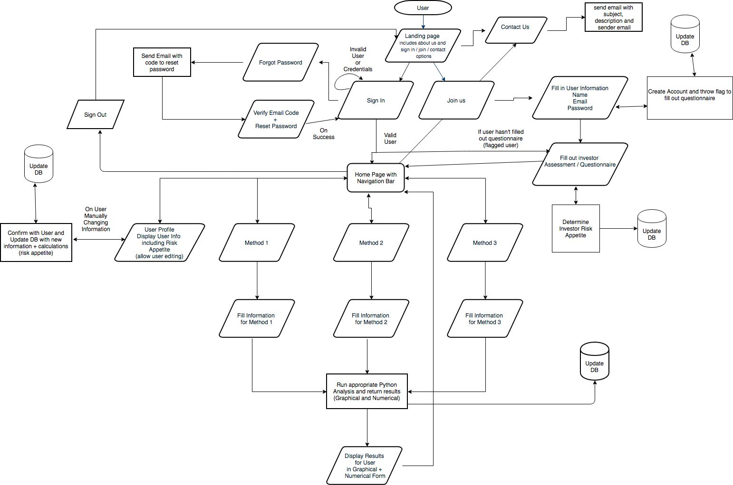

The user flow is a generic user-friendly interface for the average and unexperienced individual generated and referenced from similar Robo-Advisory websites (WealthSimple, Nest Wealth and WealthBar). The user will access the website through the hosted URL of choice and arrive at the landing page.

Landing/About Page



The landing/about page will be the first page that the user will see upon accessing the site through the URL. Upon arrival at the landing page (About), the user will be shown information about the site and our functionality as well as be given the option to sign in, join us, or contact us.

Contact Us



If contact us is selected, the user will be required to fill in information regarding what they would like to contact us about. After they have filled out the form and sent it, it will run through the back-end which will result in an email sent with the subject matter, sender, and description. The user will then be informed that their message has been sent and we will be reviewing it shortly.

Sign In



If sign in is selected, the user will be prompted to enter their user credentials which will be the typical email/password sign in method. The user will also be given the option to reset their password in the event that they forgot it.



If they press forgot password, the user will be lead to a page where they can enter an email to send a verification code to. An email will be sent to the user with a verification code required to enter on the next page. The page that follows will be a page where the user can enter the verification code and type in a new password and confirm it by re-typing the password. They will then be lead back to the sign in page where they can enter their new login credentials and access the main site.

Upon successful sign in, the user will either go to the home page which displays the different functions of the Robo-Advisor or, if they haven’t filled out the questionnaire, they will be prompted to fill it out.

Join Us



If the user selected the join-us button, they would be lead to a page that requires them to fill out a form that has the following fields: First Name, Last Name, Email, Password, and Date of Birth. The fields will be checked appropriately to ensure they are valid entries and screened before they are sent for processing. Upon completion, the information the user has provided us will be sent to the backend where a user object will be instantiated and updated in the DB with a flag thrown requiring the user to fill out the questionnaire.



The user will then be lead to a questionnaire page that asks them a series of questions to determine their risk appetite and investor mentality. The current setup for the questionnaire is a simple choose a scenario that better suits you. The business logic will decide which questions are required and will send it to the front end to populate the two options for every question. A progress bar will track and display the users’ progress through the questionnaire and allow them to go back to change their answers if they feel a change of heart. On the final question, the next button will turn into a finish button. The answers will be recorded and sent to the backend which will have the business logic integrated into it in order to calculate and determine the users’ risk tolerance. Upon successful completion, the user will be lead to the home page.

Home Page



From the Home Page the user can access the 3 different functions of the Robo-Advisor or they can navigate to view their user profile, all from the navigation bar or home page screen. The Homepage will be extremely simplistic with only the navigation bar and 3 square elements on the page that will lead them to the different functions of the Robo-Advisor. Currently, the 3 functions of the advisor (as laid out by the capstone project requirements) have been respectively named Method 1, Method 2, and Method 3. Since this is not intuitive and gives no information on their function, they will be renamed by the business logic team members and appropriately implemented in the prototype and final product.

Navigation Bar

The navigation bar will be a sticky header element that will be at the top of the page regardless of the location of the user. The user will have the option to navigate to: Homepage (through logo), Method 1, Method 2, Method 3, About(Landing page), Contact Us, and user profile page/sign out.

User Profile



When the user selects to view their user profile through the navigation bar, they will be directed to a page that contains the information pertaining to their account including name, date of birth, email, change password(button) and risk appetite. The history is currently an experimental idea and will be implemented only if the development of it doesn’t require too much time within the context of the project deadline. The user must be able to edit the information (aside from name) upon clicking an edit button or pressing change password. The risk appetite can also be manually changed here but with a warning. The resulting changes will be record and sent to the backend for validation and updating of the DB.

Sign Out

The user can choose to sign out of their account through the navigation bar under the profile section. They will be lead to the landing page if they select this option.

Method 1



On selection of Method 1, the user will be lead to a page where they will have to fill out the information required to run method 1 through the backend [to be decided exactly by the business logic]. Upon validation that the fields are not empty and are valid (in range), the info will be sent to the back end where it will undergo further validation and finally be run through the Python script to generate the required output. The output will also be back tested and stored in the database for future reference.

 The back-end will send back the result to the front end with both numerical and graphical display information where the front end will process the information to produce informative and easy to understand graphs and results. The user can navigate away from this results page through the navigation bar.

Method 2



On selection of Method 2, the user will be lead to a page where they will have to fill out the information required to run method 2 through the backend. Upon validation that the fields are not empty and are valid (in range), the info will be sent to the back end where it will undergo further validation and finally be run through the Python script to generate the required output. The output will also be back tested and stored in the database for future reference.

The back-end will send back the result to the front end with both numerical and graphical display information where the front end will process the information to produce informative and easy to understand graphs and results. The user can navigate away from this results page through the navigation bar.

Method 3



On selection of Method 3, the user will be lead to a page where they will have to fill out the information required to run method 3 through the backend. Upon validation that the fields are not empty and are valid (in range), the info will be sent to the back end where it will undergo further validation and finally be run through the Python script to generate the required output. The output will also be back tested and stored in the database for future reference.

The back-end will send back the result to the front end with both numerical and graphical display information where the front end will process the information to produce informative and easy to understand graphs and results. The user can navigate away from this results page through the navigation bar.

### 

### Gathering User Input(s) and Feedback

For gathering data, a standard form method will be used on all pages. Forms will be generated with validation built into them to ensure that initial data is feasible and sufficient. A lack of data or invalid data will result in the user being unable to continue forward or submit their input. Further data validation and confirmation will occur in the back-end where the process will also be running on valid data.

For the forms, a standard template form will be used in combination with the Form Bootstrap component. This component was selected in particular due to its simplistic implementation, beautiful design, seamless feel and excellent user experience. It is extremely well documented and the implementation is sufficiently simple so that we can use it in all of our form requiring pages.

Some elements required a little more consideration and thought than others. One such element was the decision to use a slider on the portfolio generating function (Method 3) for the time horizon. On sites such as Wealthsimple, they use sliders to allow the user the ability to see returns graphed over different time horizons. The reason we chose to go with this approach over tradition dropdown/input form options is because it not only limits the range of user input but it also allows the backend to set pre-determined methods for the different time horizons so that it can better support them instead of having a backend that is dynamic to the point of vagueness when it comes to time horizons. The slider is also extremely intuitive and easy to use for most users and should therefore propose no learning curve for any unexperienced members.

Another decision revolving around gathering data that was particularly impactful was the choice to make the questionnaire only a left or right option type of questionnaire as opposed to the traditional form questionnaire. Traditional form questionnaires are too plain, simple, boring, and non-modernized. Millennials today are very active and can’t sit through a 10-20 question form that they have to fill in one by one. It is also particularly difficult to have to set the many different ranges, input types, and values for all the different form answer types. It is with this idea in mind that we decided to follow other approaches to questionnaires which included the method that we chose. We chose a method that makes the process seamless and even fun to the user. As long as the number of questions, n, decided by the business logic is not too high (15+), the user will breeze through the questions since they only have to consider 2 options. This also restricts the number of things they can enter right down to two options so that the backend doesn’t have to deal with outlier data, ex: a user can’t select a salary that is abnormal such as $20/month. Although the structuring of the questions will require more thought and a higher level of effort to calculate the resulting risk tolerance, the user experience is tremendously impacted in a positive manner which is of the highest priority when we designed the front end.

### Display of Computed Data

For the displaying of computed data, there was a decision to be made on the method of producing and displaying graphs/other information. This decision primarily revolved around 3 different charting libraries that would make the chart displaying and implementation significantly easier. The three libraries in consideration were:

1. Bokeh
2. Plotly.js/dash
3. Chart.js

Each of the libraries had their perks and their draw backs. The following table displays some of the perks and draw backs of each of the three options.

| Library | Pros | Cons |
| --- | --- | --- |
| Bokeh | * Wider range of interactions than Dash * Large number of examples on library usage and integration with Flask | * More difficult to implement than Dash * Learning curve can be steep with little documentation and implementation |
| Plotly.js/Dash | * Very well documented * Contains a wide breadth of functions for users to filter, analyze, print, and customize when it comes to graphing * Possible to attach React components on top of the existing graph | * Charting can be complex to an unexperienced user * Integration with flask and some of the other technologies chosen in the next section is tough * Higher learning curve for implementation |
| Chart.js | * Extremely simple to use and populate graphs * Intuitive and simplistic graph display for users * Implementation and integration is not difficult * Easy integration with Jinja2 templating | * Limited graphs available to display * Graph customization is minimal |

The final decision on the library selected for creating the graphs is based on our values for the project. The greatest thing that we value is user experience and simplicity/design. That being said, Plotly.js/Dash was chosen over Bokeh even though they were extremely similar in what they can produce. The main difficulty with Bokeh is in implementation, which was directly implemented and researched to be tougher to use than Dash [[2]]. The comments on the article contain many developers that voiced their concern over the use of Bokeh while praising Dash. The main problem with Dash boiled down to the fact that Dash is built off the Flask framework. This causes a disconnect when trying to integrate Dash plots and Flask applications. We would either need a middleware dispatcher or we would have to route to a different server where the Dash plot was being held. Since this would cause significantly more work and would potentially lead to more problems, the decision then came down to one of Chart.js and Bokeh. Since we must use Flask to build a RESTful web application, we had to find a corresponding library that can work with Flask and the technologies we chose to use with it (discussed in the next section). With this in mind, we decided to go with the charting library that would best fit our values of making the user experience as great as it can be. The result was that Chart.js was selected for the graphing purposes of this application. While Chart.js has minimal charting capabilities and customization, it excels in producing simple, easy to understand, and easy to implement graphing. This reflects our priority to make the user experience as user friendly as possible without sacrificing functionality.

### Decision on Technologies Used

Styling Technologies

| Library | Pros | Cons |
| --- | --- | --- |
| Bootstrap | * Heavily documented * Plethora of examples, websites, and help forums * Beautiful and simple designs of just about everything we will need * Highly user friendly * Allows for easy customization | * Bootstrap 4 isn’t as supported by older versions of web browsers * Not necessarily better than Pure CSS and Foundation when it comes to element design |
| Pure CSS | * Very simple and minimalistic * Beautiful cascade of colours and other options for the elements | * Less comprehensive than Bootstrap or Foundation * No Icons available * Licensed by Yahoo |
| Foundation | * Used by major sites that rely on user experience (Facebook, Yahoo, EBay) * Supports a wide breadth of old and new browser versions * Similar to Bootstrap in possibilities and usage | * Learning curve is steeper than Bootstrap without prior experience in CSS |

Templating vs Frontend development Technologies

| Library | Pros | Cons |
| --- | --- | --- |
| Angularjs | * Extremely well documented * Easy to implement and deploy * Large number of elements with different functionalities for all types of usages * Integrates well with Dash and other technologies | * Usually used for SPAs (Sing Page Applications) * Client-side rendering * Steep learning curve with no prior experience |
| Jinja2 | * Default templating framework in use with Flask * Simple, easy to use * Allows for reusable elements (navbar, pages) * Allows for server-side rendering | * Limited integration with other frontend technologies like Angular * Harder to create a seamless user experience using only templates |
| React.js | * Diverse range of applications and documentation * Provides support for modular, mobile, and responsive web apps * Supported by Facebook and used by Uber, Airbnb, Twitter and more * Prior experience using React * Integrates well with Dash and other technologies | * Integration with flask can be complex at times * Newer framework with not as much support/documentation for bugs as Angular |

First and foremost, server-side rendering is a better user experience compared to just client-side rendering. The user gets the content faster, the webpage is more accessible when JS fails or is disabled, and search engines have an easier time indexing it.

## Back-End

### Storage of Financial Data (Both Raw and Computed Data)

### Cleaning Data & Dealing with Missing Data

### Choice of Database / Data Source for Raw Data

### Setup of Data Access Layer for Data (Both Raw and Computed Data)

### Hosting

### Flow Chart and Decisions on Technologies Used

(Include a DfX Analysis)

# Analysis of Service Environment

# Project Plan and Timeline

The official launch and presentation of Alpha Factory will occur on December 3rd, 2018 from 3-6pm in room 440 of the Myhal Centre for Engineering Innovation & Entrepreneurship at the University of Toronto. The Final Report and documentation of Alpha Factory will be released shortly after, but no later than 5pm on December 5th, 2018.

To ensure timely delivery, Alpha Factory has imposed an internal deadline of November 29th, 2018. Currently, they aim to have a draft of the Final Report and complete robo-advisor platform by that time. To meet these deadlines, the team has laid out the following timeline with the corresponding milestones.

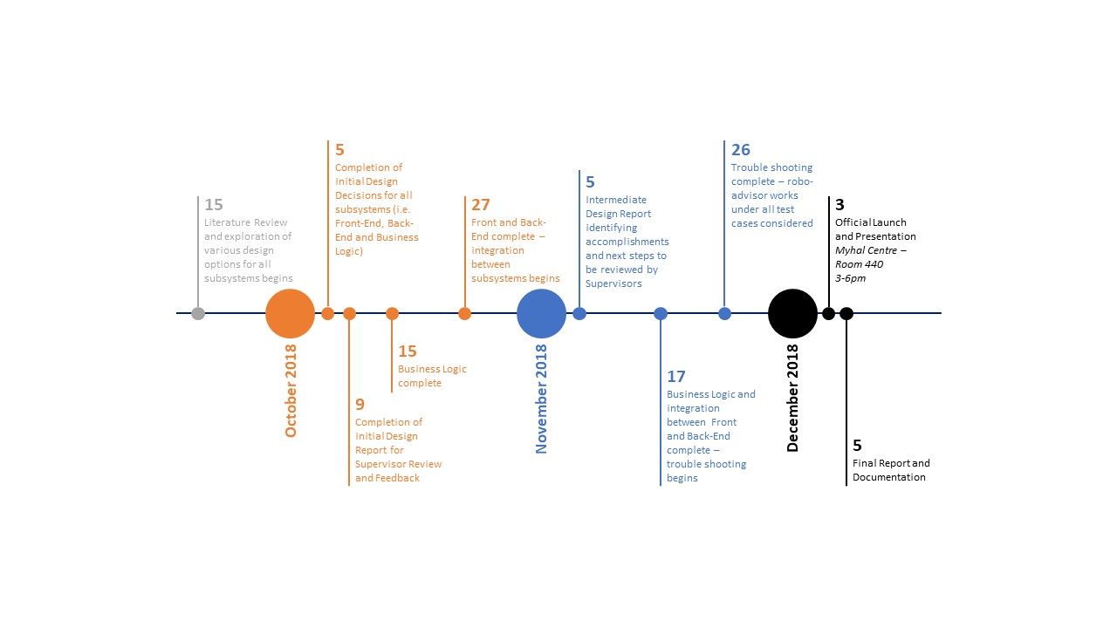

**Figure X:** Project Timeline

Additional notes regarding select milestones from Figure X above are provided in Table Y below.

| Item | Detailed Description |
| --- | --- |
| Oct 15: Business Logic complete | A completed Business Logic constitutes:   * Completion of asset selection and financial data location * Completion of portfolio generation algorithm * Completion of parameter estimation * Complete justification for all design decisions made including asset selection, portfolio generation and parameter estimation * Thorough understanding of all models and methodology used completed as part of Literature Review |
| Oct 27: Front and Back-End complete | A completed Front-End constitutes:   * Ability to gather user inputs and feedback * Ability to hook up to Business Logic and display computed data (e.g. graphs, tables, numbers, etc.) * Complete user-friendly design and user interface   A completed Back-End constitutes   * Ability to clean data and/or deal with missing data * Database selection and initialization including the ability to store raw and computed data from the financial data selected and generated by Business Logic |
| Nov 17: Integration between Business Logic and Front-End / Back-End | With the subsystems integrated, completion of this stage implies the ability to:   * Compute and present the final outcome (e.g. optimal portfolio given the user inputs) * Perform all the required analytics (e.g. backtesting, portfolio performance metric calculations, etc.) * Validate portfolios generated by the system |

**Table Y:** Detailed descriptions for select milestones

# References

1. Passive investing methods seek to avoid the fees that may occur with frequent trading. With the main goal being to build wealth gradually, the primary investment mantra of passive investment strategies is that of buying securities with the intention of holding them long term. With the underlying assumption of passive investors being that the market posts positive returns overtime, passive investment strategies do not seek to profit from short-term market fluctuations as active traders would.
2. https://blog.sicara.com/bokeh-dash-best-dashboard-framework-python-shiny-alternative-c5b576375f7f